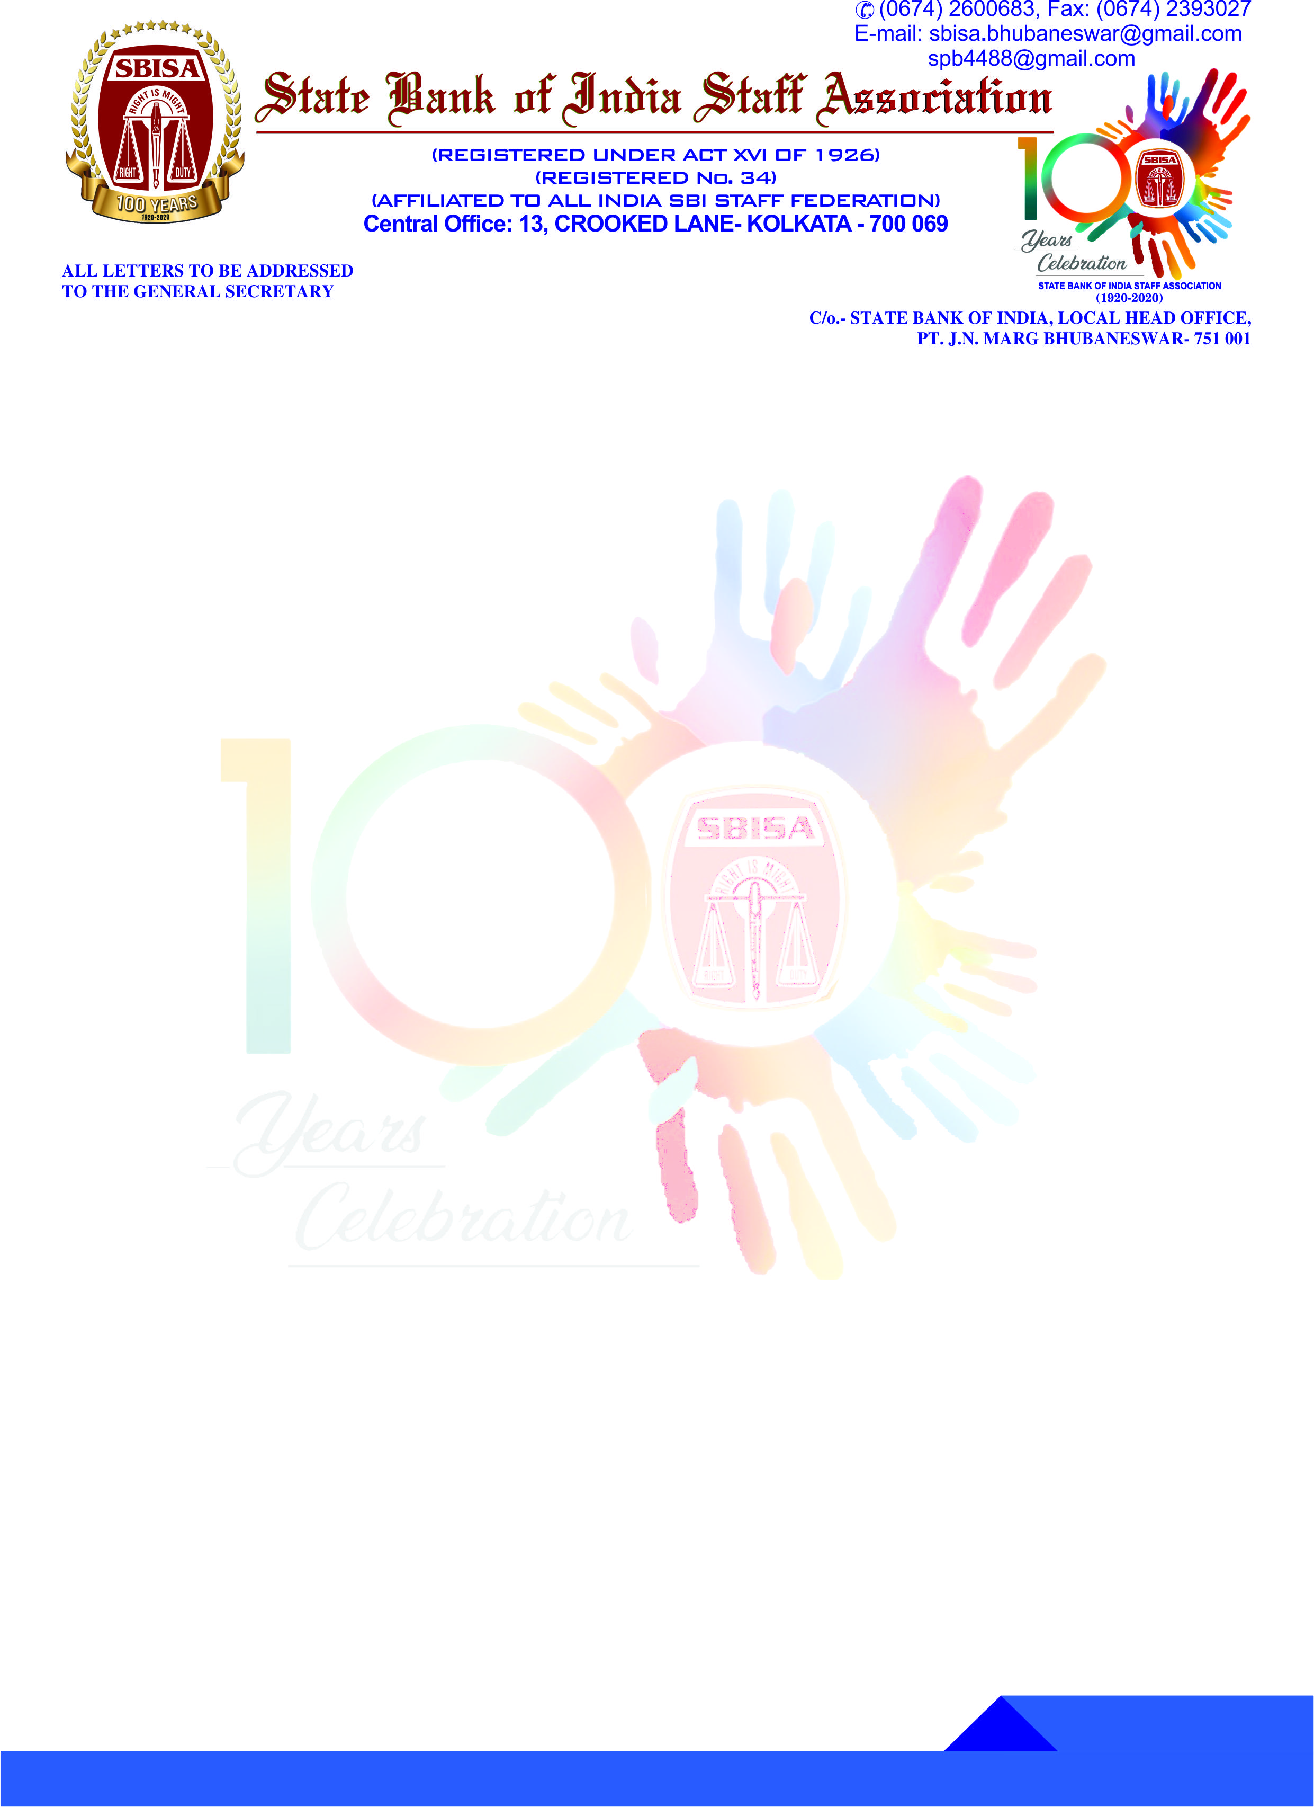

**Ref. No. : GS/212**

7th November 2019

The Chief Secretary

SBI Staff Association

(8 Circles)

Dear Comrade,

**CO-OPTION**

**COM. ANIL KUMAR PRADHAN**

**CIRCLE PRESIDENT, SBISA, BBSR CIRCLE**

Consequent upon the retirement of Com. Annada Shankar Jena, Circle President on 31st October 2019, Com. Anil Kumar Pradhan, Dy. General Secretary(Hq.) has been co-opted as Circle President at the Circle Committee Meeting held on 20th October 2019 at Rourkela. He has taken the charge of Circle President from 1st November 2019. Henceforth, all the communication relating to the Circle President will be made to him. The details of his address and mail ID is appended herewith for your information & record.

With comradely greetings.

Yours comradely,

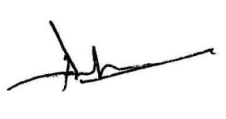

(S. P. Behera)

GENERAL SECRETARY

|  |  |
| --- | --- |
| **Com. Anil Kumar Pradhan**  Circle President  SBI Staff Association  C/o. State Bank of India,  Local Head Office  Bhubaneswar - 751001 | **Mobile No. : 9437218487**  **Email ID : anil757pradhan@gmail.com** |